

pAIRed T TEST using r

DATA SCIENCE MODELING IN R PROJECT



October 21, 2021

GANPAT UNIVERSITY

SEMESTER 5 PROJECT

This project under our Professor Dhaval Sathvara in Institute of computer technology – Ganpat University in Semester 5 and Subject Name :- Data Science Modeling in R.

URL :- https://smitrpatel.shinyapps.io/Project/

The project done by

Smit R Patel (19162121031)

Smit H Patel (19162121030)

Yash Talati (19162121047)

CODE :-

library(shiny)

library(datasets)

ui <- shinyUI(fluidPage(

titlePanel("Paired T Test"),

tabsetPanel(

tabPanel("Upload File",

titlePanel("Uploading Files"),

sidebarLayout(

sidebarPanel(

fileInput('file1', 'Choose CSV File',

accept=c('text/csv',

'text/comma-separated-values,text/plain',

'.csv')),

# added interface for uploading data from

# http://shiny.rstudio.com/gallery/file-upload.html

tags$br(),

checkboxInput('header', 'Header', TRUE),

radioButtons('sep', 'Separator',

c(Comma=',',

Semicolon=';',

Tab='\t'),

','),

radioButtons('quote', 'Quote',

c(None='',

'Double Quote'='"',

'Single Quote'="'"),

'"')

),

mainPanel(

tableOutput('contents')

)

)

),

tabPanel("Plot",

pageWithSidebar(

headerPanel('Scatter Plot'),

sidebarPanel(

# "Empty inputs" - they will be updated after the data is uploaded

selectInput('xcol', 'X Variable', ""),

selectInput('ycol', 'Y Variable', "", selected = "")

),

mainPanel(

plotOutput('MyPlot')

)

)

)

)

)

)

server <- shinyServer(function(input, output, session) {

# added "session" because updateSelectInput requires it

data <- reactive({

req(input$file1) ## ?req # require that the input is available

inFile <- input$file1

# tested with a following dataset: write.csv(mtcars, "mtcars.csv")

# and write.csv(iris, "iris.csv")

df <- read.csv(inFile$datapath, header = input$header, sep = input$sep,

quote = input$quote)

# Update inputs (you could create an observer with both updateSel...)

# You can also constraint your choices. If you wanted select only numeric

# variables you could set "choices = sapply(df, is.numeric)"

# It depends on what do you want to do later on.

updateSelectInput(session, inputId = 'xcol', label = 'X Variable',

choices = names(df), selected = names(df))

updateSelectInput(session, inputId = 'ycol', label = 'Y Variable',

choices = names(df), selected = names(df)[2])

return(df)

})

output$contents <- renderTable({

data()

})

output$MyPlot <- renderPlot({

# for a histogram: remove the second variable (it has to be numeric as well):

# x <- data()[, c(input$xcol, input$ycol)]

# bins <- nrow(data())

# hist(x, breaks = bins, col = 'darkgray', border = 'white')

# Correct way:

# x <- data()[, input$xcol]

# bins <- nrow(data())

# hist(x, breaks = bins, col = 'darkgray', border = 'white')

# I Since you have two inputs I decided to make a scatterplot

x <- data()[, c(input$xcol, input$ycol)]

plot(x)

})

})

shinyApp(ui, server)

OUTPUT :-

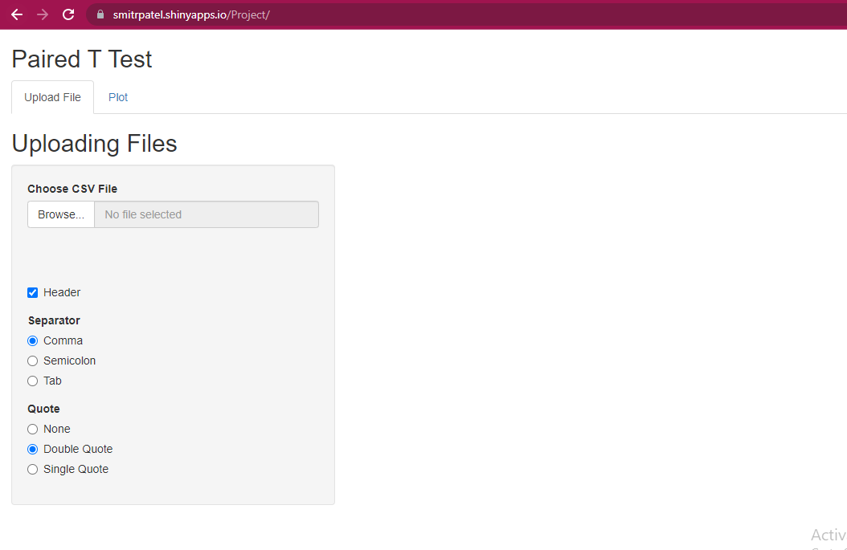

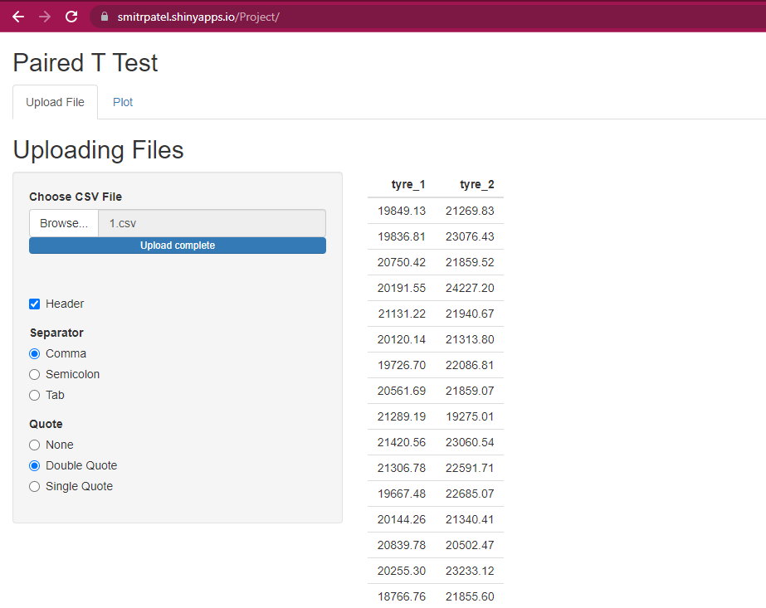

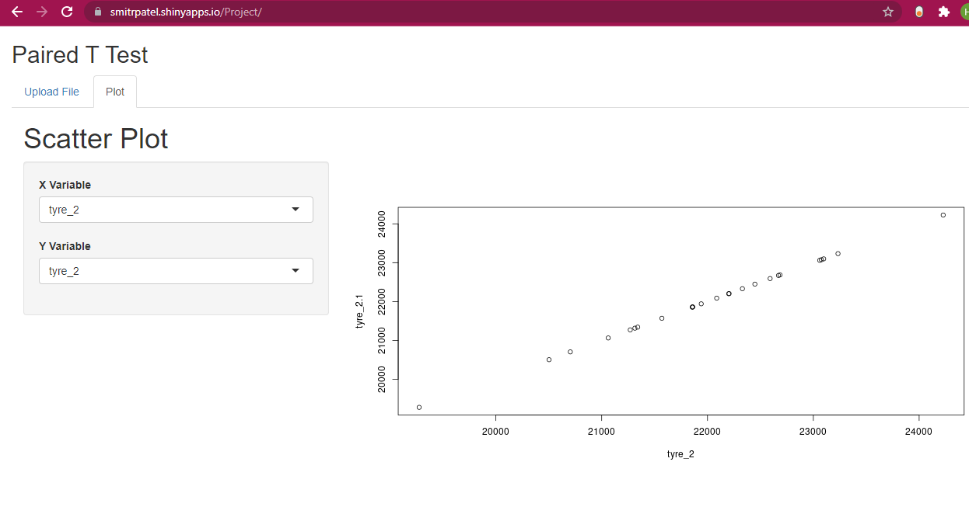

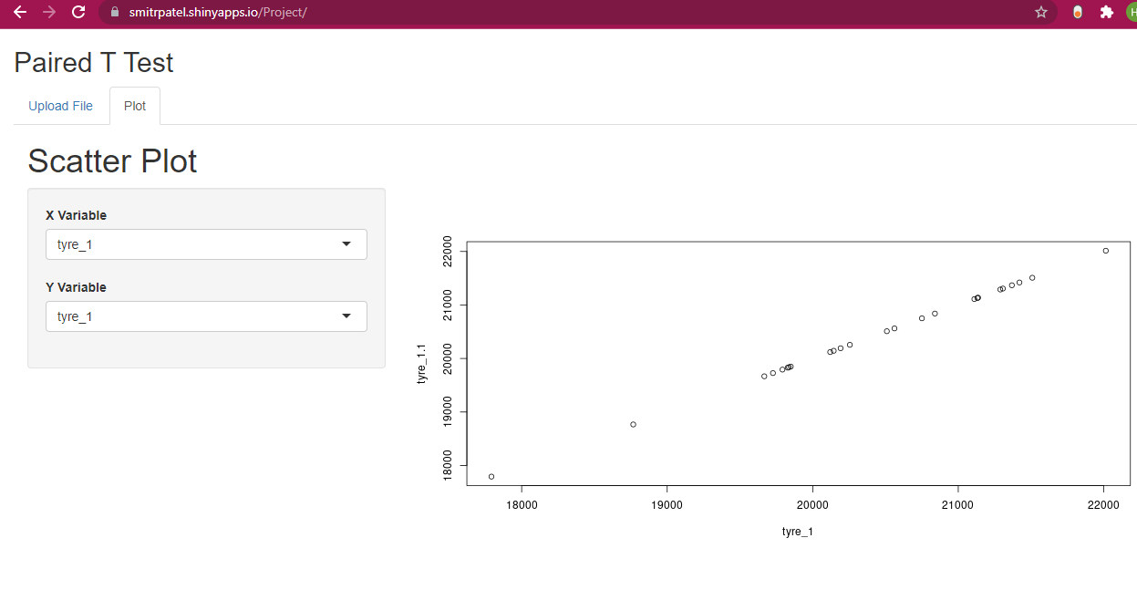

Conclusion :- In this project we learn paired t test , and hence this line show linear line and our output show in same line. So we upload on internet and learn many things using this project in data science subject.

URL :- https://smitrpatel.shinyapps.io/Project/